## Day : 04!

##### Details documentation for dynamic components and functionalities

Building a dynamic marketplace with Next.js and Shopify allows you to create a fast, scalable, and interactive e-commerce platform. This process involves integrating dynamic components such as product listings, cart management, user authentication, and real-time data fetching to deliver a seamless shopping experience. In this guide, I'll walk you through the essential components and functionalities needed to build a professional marketplace, with detailed documentation to help you implement each feature efficiently.

## Dynamic Components in Next.js

What Are Dynamic Components?

Dynamic components are those that load their content or behavior at runtime, meaning their data can change based on user interactions, external data sources, or other factors. In the case of a marketplace, products, pricing, and cart data are dynamic as they change frequently.

Next.js offers several tools to work with dynamic components, including:

* **Dynamic Routes**
* **Server-Side Rendering (SSR)**
* **Static Site Generation (SSG)**
* **Incremental Static Regeneration (ISR)**
* **API Routes**

## Dynamic Routes for Product Pages

In a marketplace, each product will have its own dynamic page. To create dynamic routes for individual product pages, use Next.js dynamic routing.

##### Example: Dynamic Product Pages

Create a dynamic product page in pages/products/[id].js:

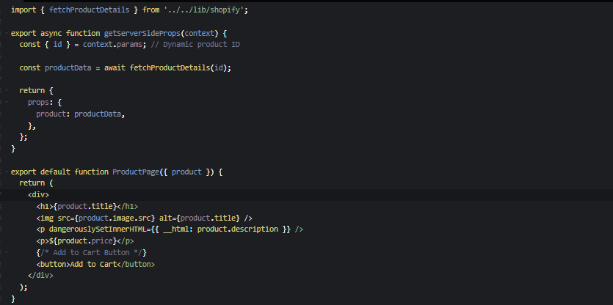

· Dynamic Route ([id].js): Here, the [id] part of the file name allows Next.js to create dynamic routes based on the product's ID.

· getServerSideProps: Fetches data for each product on the server side before rendering the page. This ensures real-time data fetching for each individual product.

## Fetching Data Dynamically (Using Shopify Storefront API)

Shopify's Storefront API is essential for fetching product data dynamically. Below is an example of how to fetch product details using the Shopify Storefront API in a function.

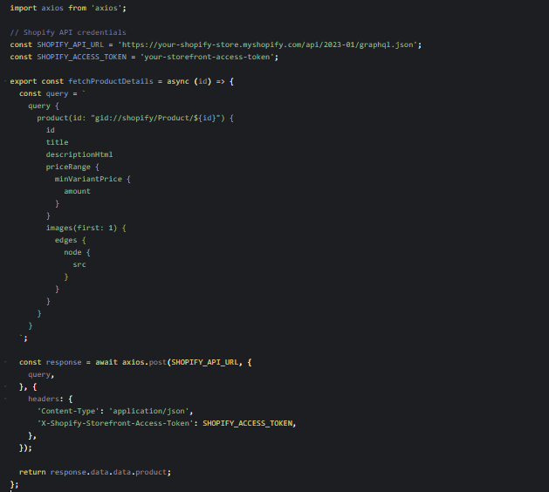

· GraphQL Query: This query fetches product details such as title, description, price, and image.

· axios: A simple HTTP client used to make the API request.

## Search & Filtering Components

Dynamic marketplaces often include product search and filtering functionality. You can create dynamic search components to filter products by attributes like price, categories, or vendor.

##### Example: Search Component with Filters

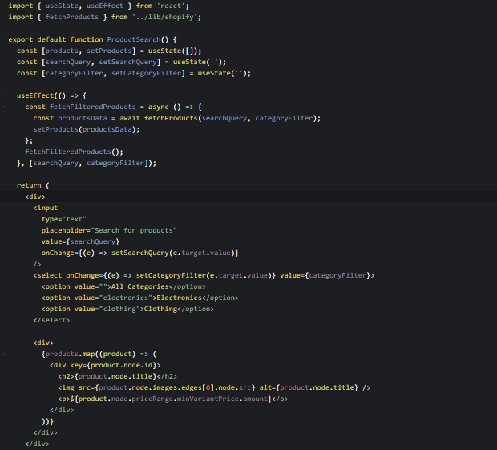

* State Management: searchQuery and categoryFilter are used to filter and search products dynamically.
* useEffect: This hook is used to trigger product data fetching whenever the search query or category filter changes.

## Shopping Cart & Checkout Functionality

For a marketplace, you need to manage a shopping cart and allow users to checkout. Shopify provides the Cart API for creating and managing carts.

##### Example: Add to Cart API

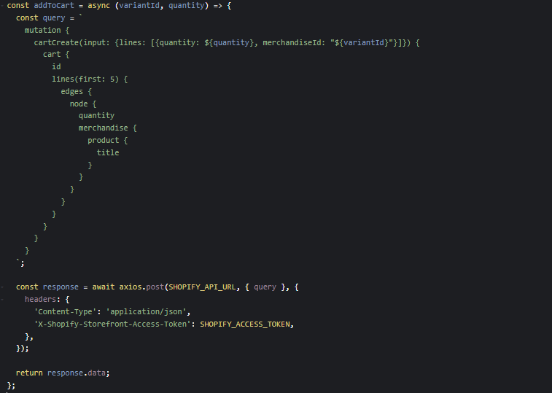

· Cart Management: The cartCreate mutation is used to add products to the cart dynamically. You can also use cartUpdate and cartRemove mutations to update the cart.

· axios: Handles the API request to Shopify.

##### Example: Cart Component

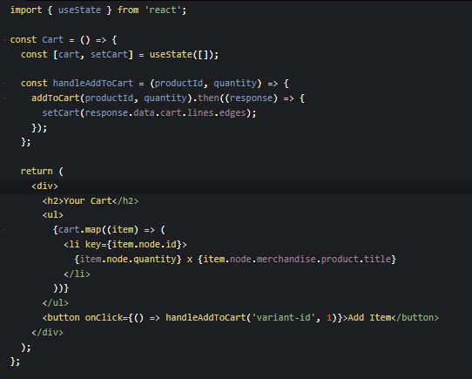

· State: Manages the cart's state.

· Cart Update: Whenever a product is added, the cart state is updated dynamically.

## User Authentication & Profile Management

For user authentication, NextAuth.js can be used for managing user login, registration, and profile management. You can integrate it with third-party authentication providers or use custom authentication methods.

##### Example: NextAuth.js Integration for User Authentication

Install NextAuth.js:



Create an API route for authentication in pages/api/auth/[...nextauth].js:

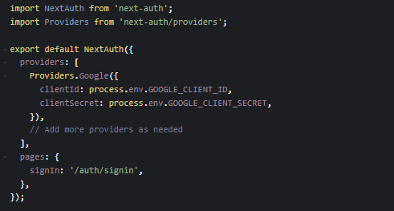

In your component, you can use NextAuth's useSession to manage user sessions:

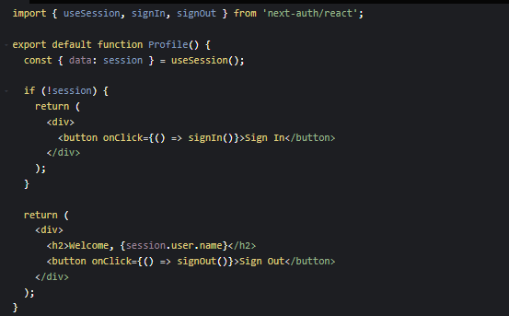

## SEO & Performance Optimization

Optimizing for SEO and performance is critical for a dynamic marketplace. Use Next.js features like Image Optimization, Static Generation (SSG), and Incremental Static Regeneration (ISR).

* Image Optimization: Use Next.js's <Image /> component to automatically optimize images.
* SEO Optimization: Use Head from next/head to add metadata to product pages, ensuring better SEO.

##### Example: Image Optimization

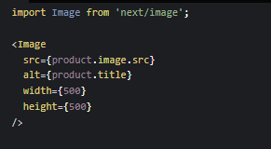

· Performance: Automatically optimizes images, serving them in the best format (WebP) and ensuring smaller image sizes for faster load times.

## Conclusion

By following this documentation, you can build a dynamic and scalable marketplace using Next.js and Shopify. This setup will allow you to implement features like dynamic product pages, cart management, user authentication, and real-time data fetching using Shopify's Storefront API.

As your marketplace grows, you can enhance its functionality by integrating more advanced features, such as managing custom user data, adding third-party services, or utilizing Shopify's Admin API for greater control over your store.